KISD 2017-2018 Chuckwagon Novel List

A Whole New Ballgame- Phil Bildner
​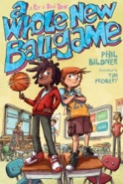
Fifth grade is one crazy ride in this middle grade novel about two best friends.
Rip and Red are best friends whose fifth-grade year is nothing like what they expected. They have a crazy new tattooed teacher named Mr. Acevedo, who doesn't believe in tests or homework and who likes off-the-wall projects, the more "off" the better. And guess who's also their new basketball coach? Mr. Acevedo! Easy-going Rip is knocked completely out of his comfort zone. And for Red, who has autism and really needs things to be exactly a certain way, the changes are even more of a struggle. But together these two make a great duo who know how to help each other—and find ways to make a difference—in the classroom and on the court.

Flashback Four: The Lincoln Project- Dan Gutman
​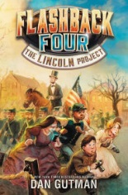

In New York Times bestselling author Dan Gutman's all-new series, which blends fascinating real history with an action-packed and hilarious adventure, four very different kids are picked by a mysterious billionaire to travel through time and photograph some of history's most important events. This time, the four friends are headed to 1863 to catch Abraham Lincoln delivering his famous Gettysburg Address. They'll have to work together to ask the right questions, meet the right people, and capture the right moment. And most important—not get caught!

Manatee Rescue by Nicola Davies
​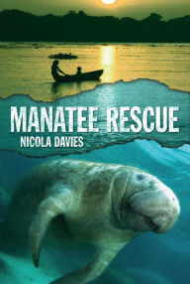
Manuela had imagined that killing a manatee would be like killing a very big fish, just more exciting. But when her father successfully harpoons one, leaving its baby orphaned, she finds that her feelings have changed. She vows to rescue the baby manatee and return it to the river. But she soon realizes what an enormous task she’s taken on. Will she be able to save the baby manatee—and protect him from being hunted in the future, too?

Red: The True Story of Red Riding Hood: Liesl Shurtliff
​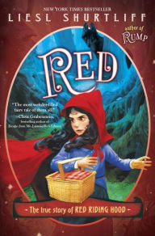

Red is not afraid of the big bad wolf. She’s not afraid of anything . . . except magic. But when Red’s granny falls ill, it seems that only magic can save her, and fearless Red is forced to confront her one weakness.
With the help of a blond, porridge-sampling nuisance called Goldie, Red goes on a quest to cure Granny. Her journey takes her through dwarves’ caverns to a haunted well and a beast’s castle. All the while, Red and Goldie are followed by a wolf and a huntsman—two mortal enemies who seek the girls’ help to defeat each other. And one of them just might have the magical solution Red is looking for. . . .

Slacker- Gordon Korman
​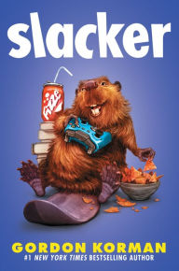
Cameron Boxer is very happy to spend his life avoiding homework, hanging out with his friends, and gaming for hours in his basement. It's not too hard for him to get away with it . . . until he gets so caught up in one game that he almost lets his house burn down around him.
Oops.
It's time for some serious damage control--so Cameron and his friends invent a fake school club that will make it seem like they're doing good deeds instead of slacking off. The problem? Some kids think the club is real--and Cameron is stuck being president.
Soon Cameron is part of a mission to save a beaver named Elvis from certain extinction. Along the way, he makes some new friends--and some powerful new enemies. The guy who never cared about anything is now at the center of everything . . . and it's going to take all his slacker skills to win this round.

The Bad Guys-Aaron Blabey
​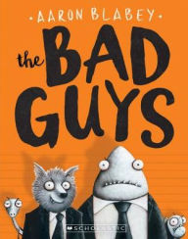
They sound like bad guys, they look like bad guys . . . and they even smell like bad guys. But Mr. Wolf, Mr. Piranha, Mr. Snake, and Mr. Shark are about to change all of that...
Mr. Wolf has a daring plan for the Bad Guys' first good mission. They are going to break two hundred dogs out of the Maximum Security City Dog Pound. Will Operation Dog Pound go smoothly? Will the Bad Guys become the Good Guys? And will Mr. Snake please stop swallowing Mr. Piranha?!

The War that Saved My Life- Kimberly Brukbaker Bradley
​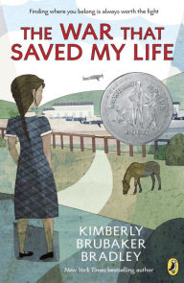
Nine-year-old Ada has never left her one-room apartment. Her mother is too humiliated by Ada’s twisted foot to let her outside. So when her little brother Jamie is shipped out of London to escape the war, Ada doesn’t waste a minute—she sneaks out to join him.
So begins a new adventure of Ada, and for Susan Smith, the woman who is forced to take the two kids in. As Ada teaches herself to ride a pony, learns to read, and watches for German spies, she begins to trust Susan—and Susan begins to love Ada and Jamie. But in the end, will their bond be enough to hold them together through wartime? Or will Ada and her brother fall back into the cruel hands of their mother?

The Wild Robot- Peter Brown
​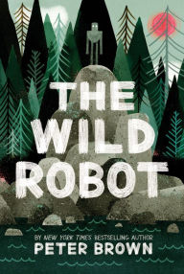
When robot Roz opens her eyes for the first time, she discovers that she is alone on a remote, wild island. She has no idea how she got there or what her purpose is—but she knows she needs to survive. After battling a fierce storm and escaping a vicious bear attack, she realizes that her only hope for survival is to adapt to her surroundings and learn from the island's unwelcoming animal inhabitants.

Word of Mouse by Patterson
​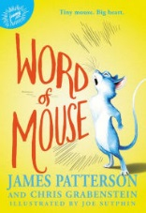
What makes Isaiah so unique? First, his fur is as blue as the sky--which until recently was something he'd never seen, but had read all about. That's right--Isaiah can read, and write. He can also talk to humans...if any of them are willing to listen! After a dramatic escape from a mysterious laboratory, Isaiah is separated from his "mischief" (which is the word for a mouse family), and has to use his special skills to survive in the dangerous outdoors, and hopefully find his missing family. But in a world of cruel cats, hungry owls, and terrified people, it's hard for a young, lone mouse to make it alone. When he meets an equally unusual and lonely human girl named Hailey, the two soon learn that true friendship can transcend all barriers.

